SEC Form 4

FORM 4

Check this box if no longer subject to Section 16. Form 4 or Form 5 obligations may continue. See Instruction 1(b).

UNITED STATES SECURITIES AND EXCHANGE COMMISSION
Washington, D.C. 20549
 |  | OMB APPROVAL
STATEMENT OF CHANGES IN BENEFICIAL OWNERSHIP
 |  | OMB Number: | 3235-0287
 |  | Estimated average burden
Filed pursuant to Section 16(a) of the Securities Exchange Act of 1934 |  | hours per response: | 0.5
or Section 30(h) of the Investment Company Act of 1940
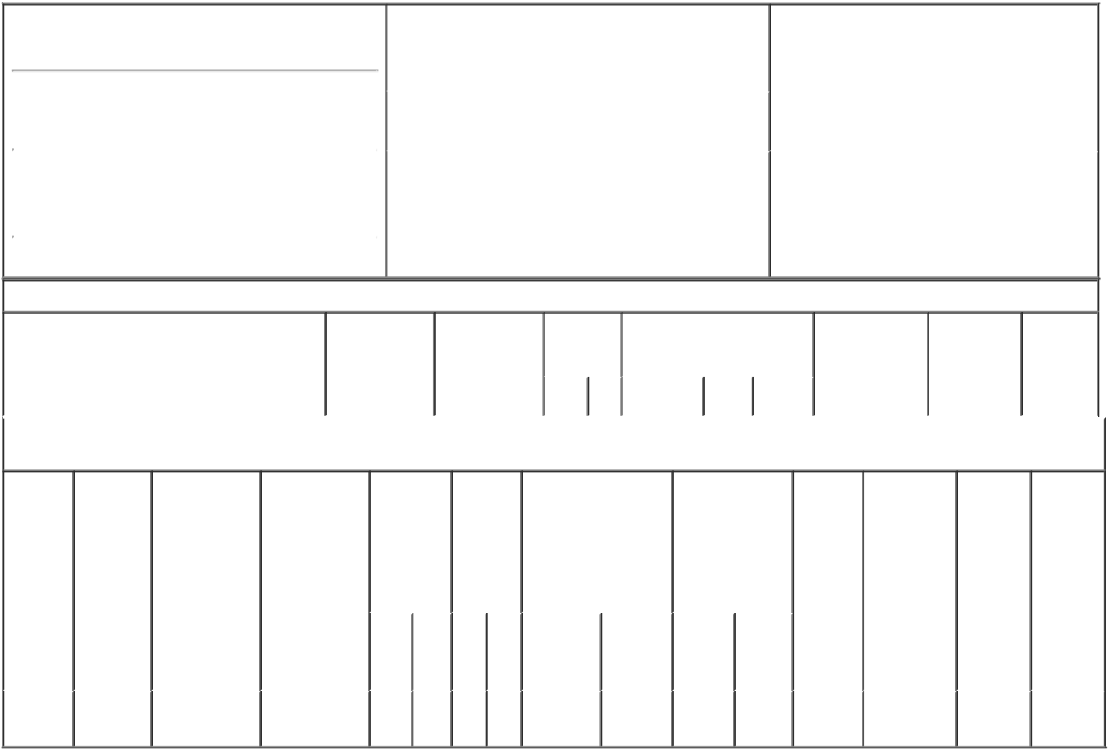

1. Name and Address of Reporting Person*
Tutas David A.

 | (Last) | (First) | (Middle)
 | 2801 EAST BELTLINE NE
(Street)
 | GRAND | MI | 49525
 | RAPIDS
 | (City) | (State) | (Zip)

 | 2. Issuer Name and Ticker or Trading Symbol |  | 5. Relationship of Reporting Person(s) to Issuer
 | UNIVERSAL FOREST PRODUCTS INC [ |  | (Check all applicable)
 | UFPI ] |  |  | Director | 10% Owner
 |  |  | X | Officer (give title | Other (specify
 |  |  |  | below) | below)
 | 3. Date of Earliest Transaction (Month/Day/Year) |  |  | Chief Comp Off, Gen Csl, Secty
11/27/2019
 | 4. If Amendment, Date of Original Filed (Month/Day/Year) |  | 6. Individual or Joint/Group Filing (Check Applicable
Line)
X Form filed by One Reporting Person

Form filed by More than One Reporting
Person

Table I - Non-Derivative Securities Acquired, Disposed of, or Beneficially Owned

 | 1. Title of Security (Instr. 3) | 2. Transaction | 2A. Deemed | 3. | 4. Securities Acquired (A) or |  |  | 5. Amount of | 6. Ownership | 7. Nature
 |  | Date | Execution Date, | Transaction | Disposed Of (D) (Instr. 3, 4 and |  |  | Securities | Form: Direct | of Indirect
 |  | (Month/Day/Year) | if any | Code (Instr. | 5) |  |  | Beneficially | (D) or Indirect | Beneficial
 |  |  | (Month/Day/Year) | 8) |  |  |  | Owned Following | (I) (Instr. 4) | Ownership
 |  |  |  |  |  |  |  | Reported |  | (Instr. 4)
 |  |  |  | Code V | Amount | (A) or | Price | Transaction(s)
 |  |  |  |  |  | (D) |  | (Instr. 3 and 4)

Table II - Derivative Securities Acquired, Disposed of, or Beneficially Owned

(e.g., puts, calls, warrants, options, convertible securities)

1. Title of | 2. | 3. Transaction | 3A. Deemed | 4. | 5. Number | 6. Date Exercisable and |  | 7. Title and |  | 8. Price of | 9. Number of | 10. | 11. Nature
Derivative | Conversion | Date | Execution Date, | Transaction | of | Expiration Date |  | Amount of |  | Derivative | derivative | Ownership | of Indirect
Security | or Exercise | (Month/Day/Year) | if any | Code (Instr. | Derivative | (Month/Day/Year) |  | Securities |  | Security | Securities | Form: | Beneficial
(Instr. 3) | Price of |  | (Month/Day/Year) | 8) | Securities |  |  | Underlying |  | (Instr. 5) | Beneficially | Direct (D) | Ownership
 | Derivative |  |  |  | Acquired |  |  | Derivative Security |  |  | Owned | or Indirect | (Instr. 4)
 | Security |  |  |  | (A) or |  |  | (Instr. 3 and 4) |  |  | Following | (I) (Instr. 4)
 |  |  |  |  | Disposed |  |  |  |  |  | Reported
 |  |  |  |  | of (D) |  |  |  |  |  | Transaction(s)
 |  |  |  |  | (Instr. 3, 4 |  |  |  |  |  | (Instr. 4)
 |  |  |  |  | and 5)
 |  |  |  |  |  |  |  |  | Amount
 |  |  |  |  |  |  |  |  | or
 |  |  |  |  |  |  |  |  | Number
 |  |  |  |  |  | Date | Expiration |  | of
 |  |  |  | Code V | (A) (D) | Exercisable | Date | Title | Shares
Phantom | (1) |  |  |  |  | (2) | (2) | Common | 15
Stock |  | 11/27/2019 |  | A | 15 |  |  |  |  | $50.05 | 15,257 | D
 |  |  |  |  |  |  |  | Stock
Units

Explanation of Responses:

- 1-for-1

- The phantom stock units were accrued under the Company's Deferred Compensation Plan and are payable in shares of the Company's common stock until the reporting person's death, disabiity or retirement.

Remarks:

/s/ Christina A. Holderman,
Attorney-In-Fact for David A. 12/02/2019
Tutas

** Signature of Reporting Person Date

Reminder: Report on a separate line for each class of securities beneficially owned directly or indirectly.

* If the form is filed by more than one reporting person, see Instruction 4 (b)(v).

- Intentional misstatements or omissions of facts constitute Federal Criminal Violations See 18 U.S.C. 1001 and 15 U.S.C. 78ff(a). Note: File three copies of this Form, one of which must be manually signed. If space is insufficient, see Instruction 6 for procedure.
Persons who respond to the collection of information contained in this form are not required to respond unless the form displays a currently valid OMB Number.

